

|  |
| --- |
| Data Migration |
| Apparel & Footwear |
|  |

**Data Migration Apparel and Footwear**

**www.argentisconsulting.com**

This document contains the necessary information to prepare and execute data migration only for Apparel & Footwear data. Therefore, all standard data migration must be referred to SAP.

**Initial Settings Apparel and Footwear**

Before performing data migration, the following setting must be initialized in the company database.

* **Segmentation:**

Apparel and Footwear 🡪 Administration 🡪 Inventory 🡪 Items Segmentations 🡪 Apparel and Footwear Segmentation

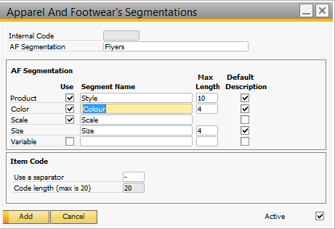

* **Collection:**

Apparel and Footwear 🡪 Administration 🡪 Setup 🡪 Design Management 🡪 Collection

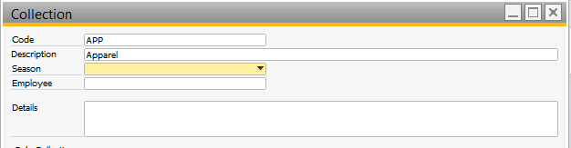

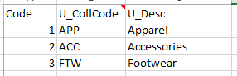

* **Sub- Collection:**

Apparel and Footwear 🡪 Administration 🡪 Setup 🡪 Design Management 🡪 Collection

And from the Collection select the option Add-Subcolection.

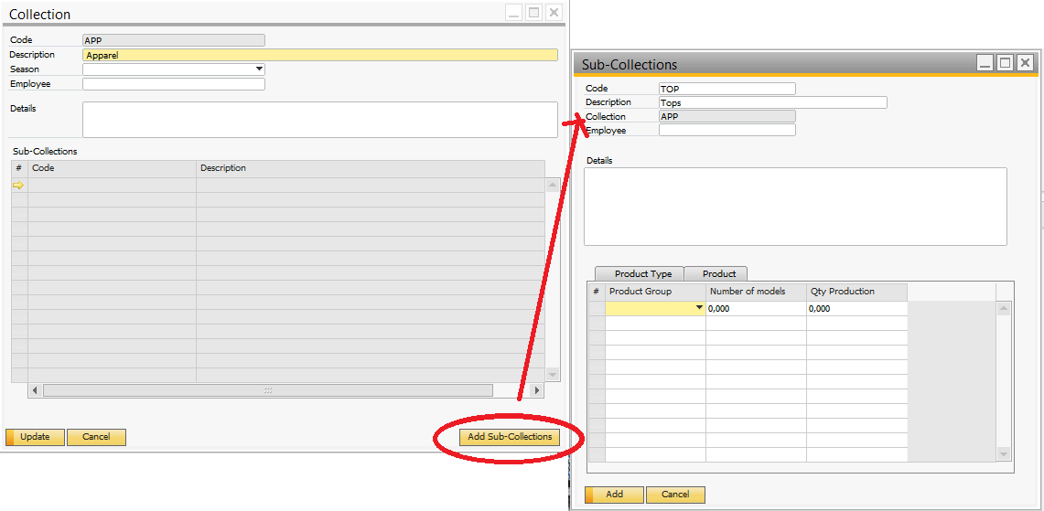

The Sub-Collections can be link to several Products Group.

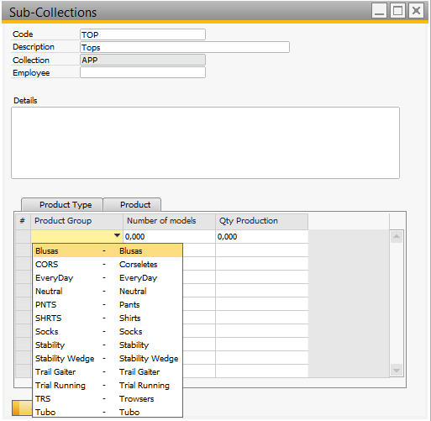

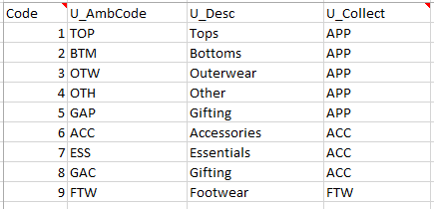

* **Status:**

Apparel and Footwear 🡪 Administration 🡪 Setup 🡪 Design Management 🡪 Style Status

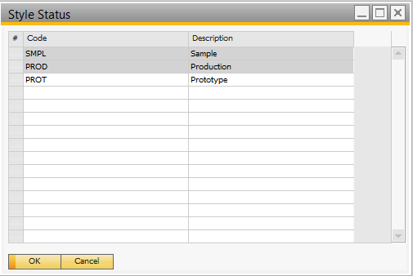

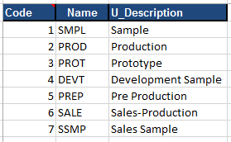

**Data Migration Procedure**

In order to start the data migration process, open the Apparel & footwear Migration Tool from the installation package.

Connect to the SAP Company Database

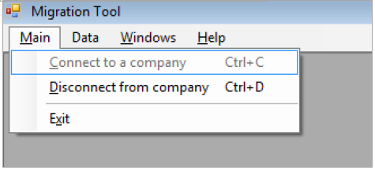

Enter license and database server name, company database, user and password

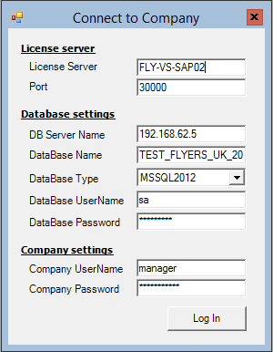

Hana

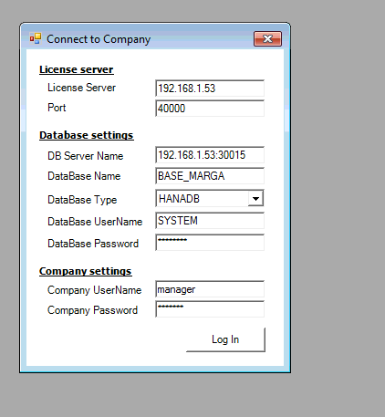

* **Components**

Excel File

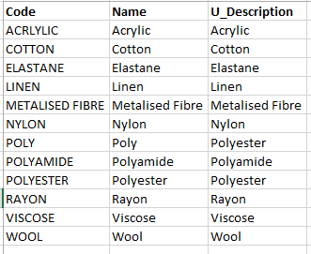

Data Migration Tool

Data 🡪 User Defined Tables (UDT) 🡪 Add Data

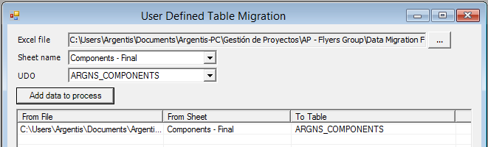

* **Composition**

Excel File

Composition

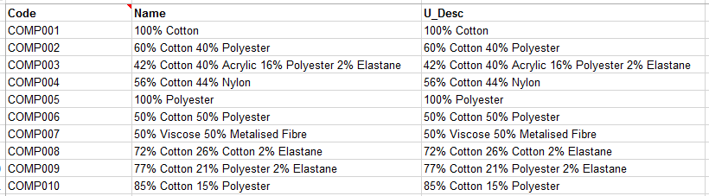

Composition Lines

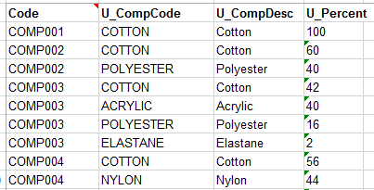

Data Migration Tool

Data 🡪 User Defined Objects (UDO) 🡪 Add Data

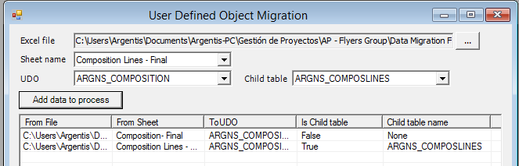

* **Product Lines**

Excel File

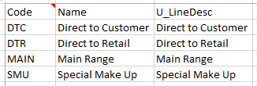

Data Migration Tool

Data 🡪 User Defined Objects (UDO) 🡪 Add Data

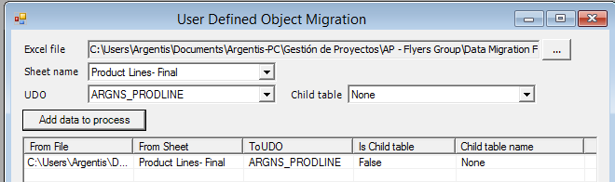

* **Product Groups**

Excel File

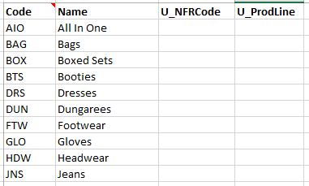

Data Migration Tool

Data 🡪 User Defined Tables (UDT) 🡪 Add Data

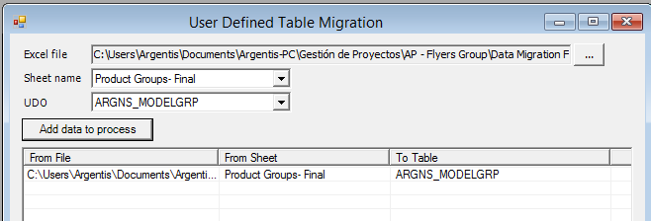

* **Brands**

Excel File

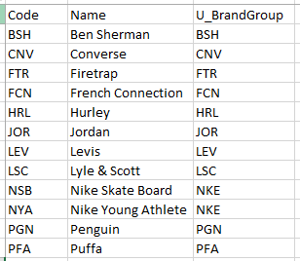

Data Migration Tool

Data 🡪 User Defined Tables (UDT) 🡪 Add Data

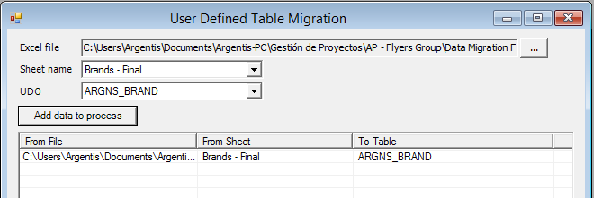

* **Color Master**

Excel File

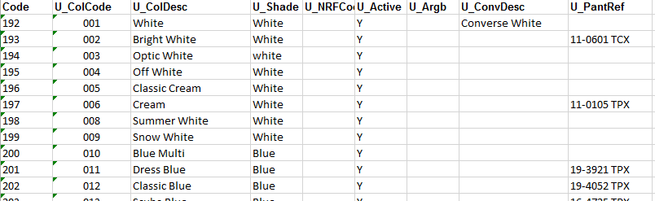

Data Migration Tool

Data 🡪 User Defined Objects (UDO) 🡪 Add Data

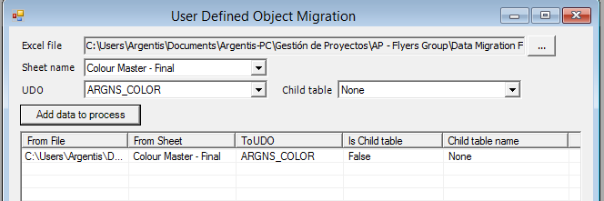

* **Scale and Size Master**

Excel File

Scale information

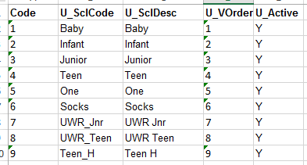

Size Information

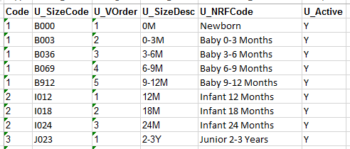

Data Migration Tool

Data 🡪 User Defined Objects (UDO) 🡪 Add Data

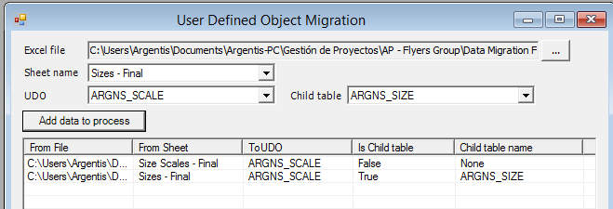

* **Style Master**

Finally, once you have the color and styles libraries, you can run data migration for the styles and child information (sizes and colors).

Data Migration Tool

Data 🡪 User Defined Objects (UDO) 🡪 Add Data

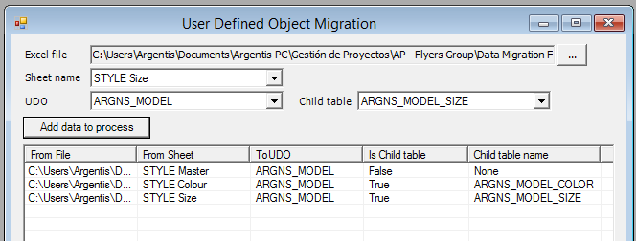

* **Default Bin Warehouse – Style level**

Excel File

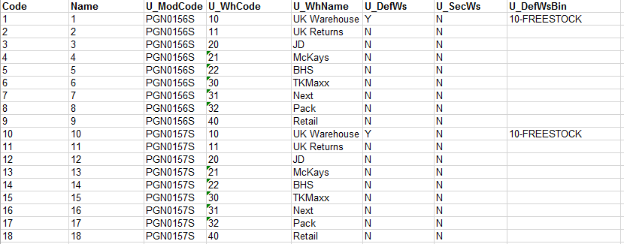

Data Migration Tool

Data 🡪 User Defined Tables (UDT) 🡪 Add Data

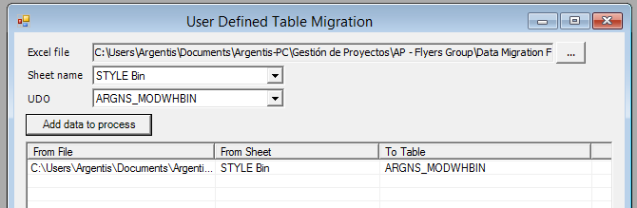

To look for the Last Internal number for Styles go to:

Data 🡪 User Defined Objects (UDO) 🡪 View/Delete data.

Select UDO ARGNS_MODEL

Search the last Register and complete the Files with the following number.

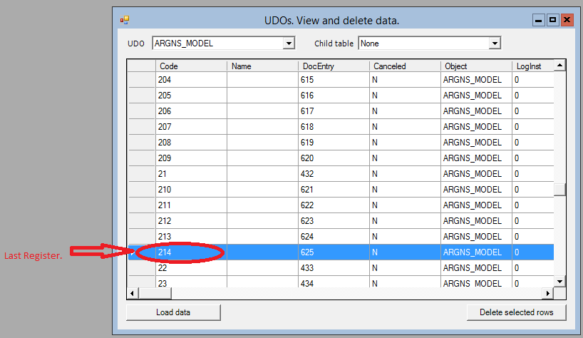

To look for the Last Internal number for Bins go to:

Data 🡪 User Defined Tables (UDT) 🡪 View/Delete data.

Select UDT ARGNS_MODWHBIN

Search the last Register and complete the Files with the following number.

* **Default Bin Warehouse – sku´s level**

How to assign a Default Bin to an item through DTW.

Assumptions: The items have already been created and/or imported into SAP.

Identify your Bins. In order to associate items to bins, first identify the BINs that have been configured in the system. A query to the OITW table should show this information.

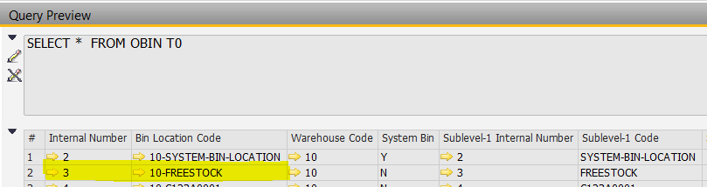

For this example, we want to assign the bin **10-FREESTOCK** to as default bin for an item.

The key fields are:

* Internal Number (DB Field name: AbsEntry)
* Bin Location Code (DB Field name: BinCode)
* Warehouse Code (DB Field name: WhsCode)

The table that creates the relation between an item and its default bin is the OITW table. Fill in the template corresponding to this table with the following information:

* ParentKey (DB field name: ItemCode) – The ItemCode of the item in SAP that we want to update (OITM)
* WarehouseCode (DB field name: WhsCode) – The default warehouse code defined for the item (OITM)
* DefaultBin (DB field name: DftBinAbs) – This is the Internal number (or AbsEntry) from the previous step.
* Information about the rest of the fields in this template has been omitted since it is not necessary for this process.

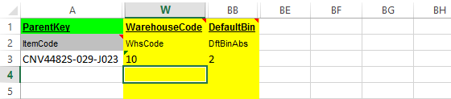

Once this template is ready, follow the standard procedure to import this information using DTW.

Login to the SAP Company and click the “Import” button.

1. Select **Master Data** as Data Type
2. Select **Update Existing Data** as Operation Type
3. For the Business Object, select **Inventory** and then **Item Master Data**
4. Select the csv template with the items and their default warehouse information as data source for the ItemWarehouseInfo.  
     
   Screenshot added for further reference:  
   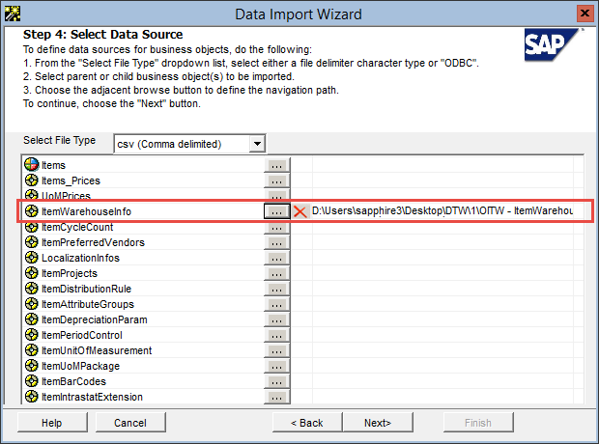
5. Continue with the wizard to complete the import process.

Once this is complete, you should be able to see the default bin for each of the items in SAP.



**www.argentisconsulting.com**

|  |  |
| --- | --- |
| **USA**  9744 NW 45th Lane  Doral, FL 33178  info@argentisconsulting.com | **ARGENTINA**  Ávila y Zarate 2048  Cerro de la Rosas, Córdoba,  CP 5009  Córdoba - Argentina  info@argentisconsulting.com |
| **CARIBEAN**  City View Plaza – Suite 301  48 Road 165  Guaynabo, PR. 00968  Puerto Rico  caribe@argentisconsulting.com | **SPAIN**  C/ Juan Bravo N° 3 A 28006  Phone: (+34) 91 123 7263  Madrid - Spain  info@argentisconsulting.com |

**INFORMACIÓN DE CONTACTO**

**Argentis Consulting** is dedicated to the development, distribution   
and support of recognized certified solutions for SAP Business One.   
As an SAP Software Service Provider Partner with Gold Status.